Policies_Verifying Agency Billed Policy_Instance43_29-May-2018_03-44-07_AM_ValidationofAgencyBilledPolicy.png

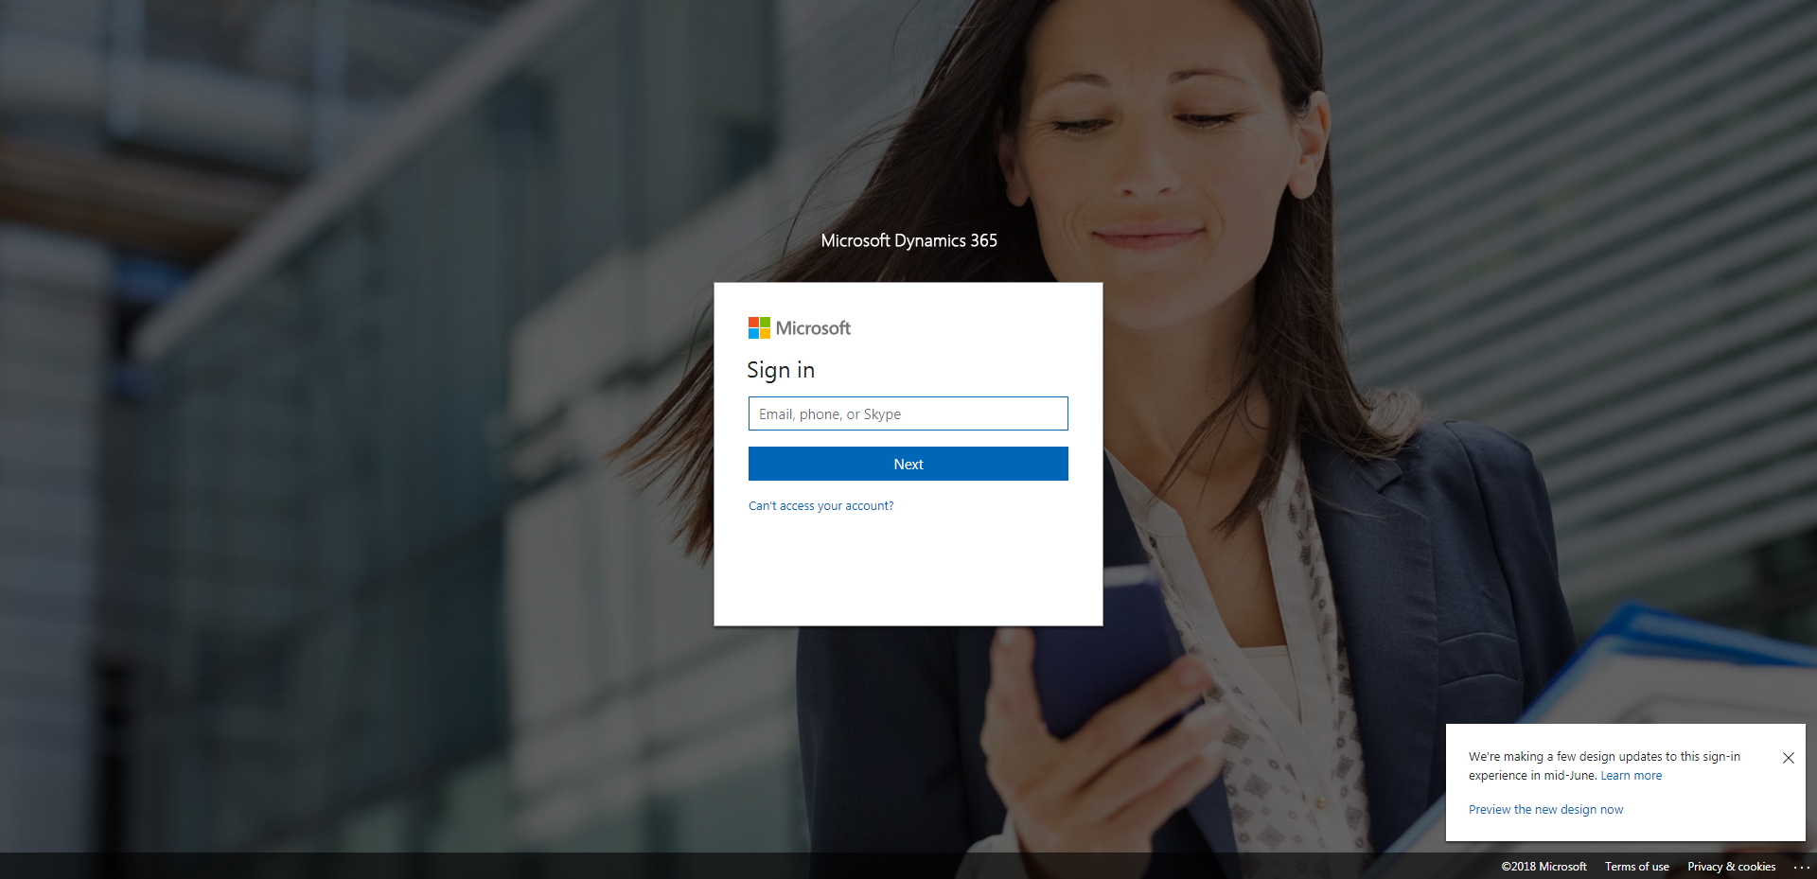

Policies_Verifying Agency Billed Policy_Instance43_29-May-2018_03-44-04_AM_SingleSignOn.png

